**Links to videos**

<https://youtu.be/fj17B-hsJWM?si=RRxmcj3mZ0baTB1a>

<https://youtu.be/dvTWV58U8BY?si=gS-eQbd-FkkiLxX>

**Screenshots of the application**

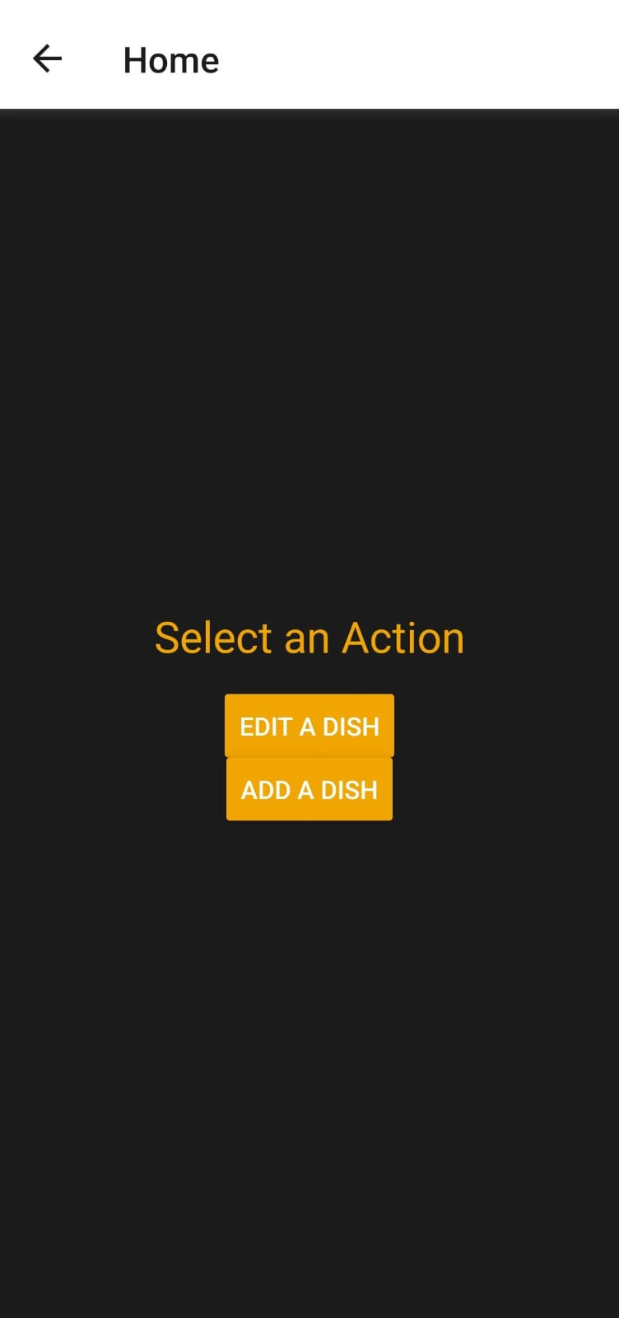 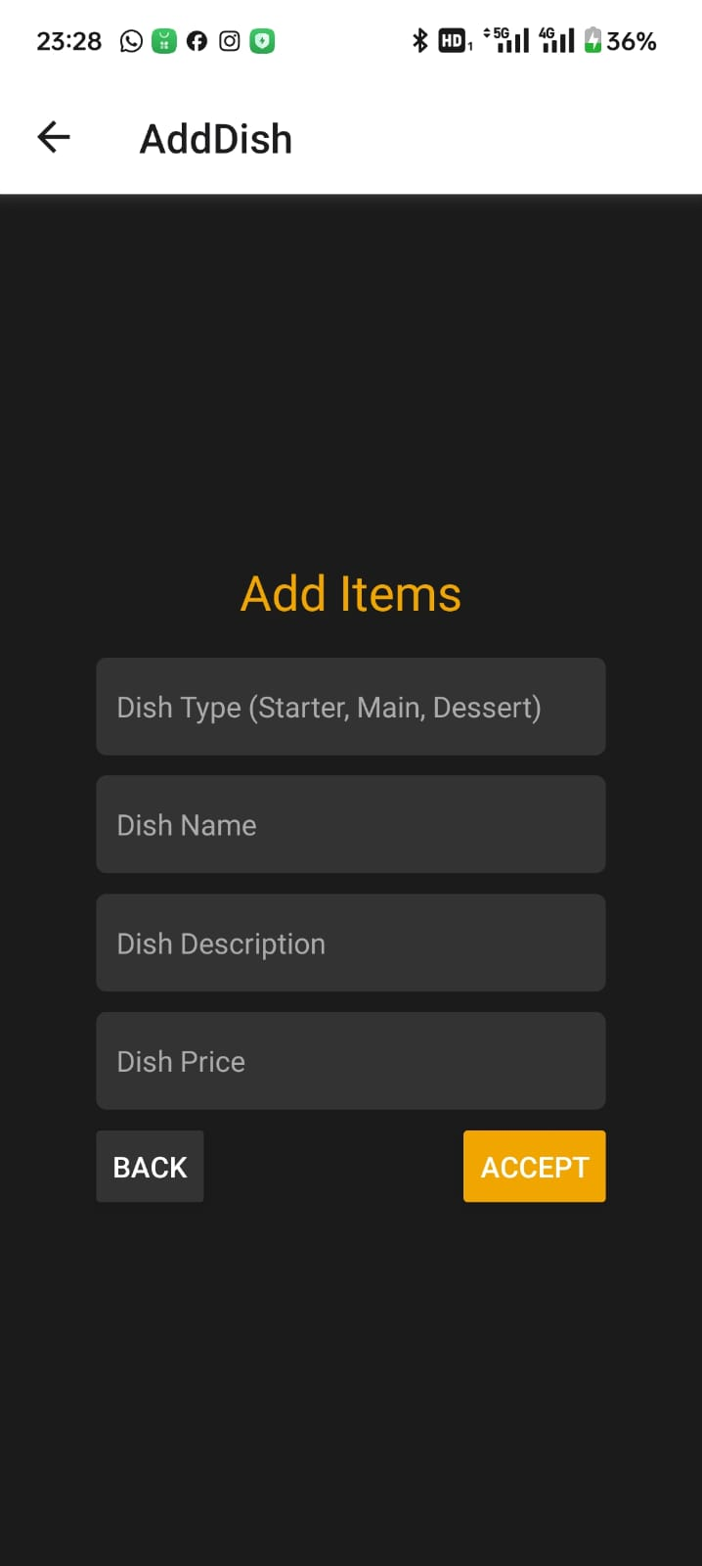

**Home page**

On this page you are able to either edit a dish or add a dish. These buttons will take you to your next screens

**Add items/edit items**

These screens are identical apart from the heading prompt, you are required to follow each text box prompt so that you can add the necessary details to the dishes.

**Copy of code**

import React, { useState } from 'react';

import { NavigationContainer } from '@react-navigation/native';

import { createStackNavigator } from '@react-navigation/stack';

import { View, Text, Button, TextInput, StyleSheet, ScrollView } from 'react-native';

const Stack = createStackNavigator();

const HomeScreen = ({ navigation }) => {

  return (

    <View style={styles.container}>

      <Text style={styles.title}>Select an Action</Text>

      <Button title="Edit a Dish" onPress={() => navigation.navigate('EditDish')} color="#f0a500" />

      <Button title="Add a Dish" onPress={() => navigation.navigate('AddDish')} color="#f0a500" />

    </View>

  );

};

const AddDishScreen = ({ navigation }) => {

  const [dishType, setDishType] = useState('');

  const [dishName, setDishName] = useState('');

  const [dishDescription, setDishDescription] = useState('');

  const [dishPrice, setDishPrice] = useState('');

  return (

    <View style={styles.container}>

      <Text style={styles.title}>Add Items</Text>

      <TextInput

        placeholder="Dish Type (Starter, Main, Dessert)"

        style={styles.input}

        placeholderTextColor="#aaa"

        value={dishType}

        onChangeText={setDishType}

      />

      <TextInput

        placeholder="Dish Name"

        style={styles.input}

        placeholderTextColor="#aaa"

        value={dishName}

        onChangeText={setDishName}

      />

      <TextInput

        placeholder="Dish Description"

        style={styles.input}

        placeholderTextColor="#aaa"

        value={dishDescription}

        onChangeText={setDishDescription}

      />

      <TextInput

        placeholder="Dish Price"

        style={styles.input}

        placeholderTextColor="#aaa"

        keyboardType="numeric"

        value={dishPrice}

        onChangeText={setDishPrice}

      />

      <View style={styles.buttonRow}>

        <Button title="Back" onPress={() => navigation.goBack()} color="#333" />

        <Button title="Accept" onPress={() => alert('Dish Added!')} color="#f0a500" />

      </View>

    </View>

  );

};

const EditDishScreen = ({ navigation }) => {

  const [dishType, setDishType] = useState('');

  const [dishName, setDishName] = useState('');

  const [dishDescription, setDishDescription] = useState('');

  const [dishPrice, setDishPrice] = useState('');

  return (

    <View style={styles.container}>

      <Text style={styles.title}>Edit Items</Text>

      <TextInput

        placeholder="Dish Type (Starter, Main, Dessert)"

        style={styles.input}

        placeholderTextColor="#aaa"

        value={dishType}

        onChangeText={setDishType}

      />

      <TextInput

        placeholder="Dish Name"

        style={styles.input}

        placeholderTextColor="#aaa"

        value={dishName}

        onChangeText={setDishName}

      />

      <TextInput

        placeholder="Dish Description"

        style={styles.input}

        placeholderTextColor="#aaa"

        value={dishDescription}

        onChangeText={setDishDescription}

      />

      <TextInput

        placeholder="Dish Price"

        style={styles.input}

        placeholderTextColor="#aaa"

        keyboardType="numeric"

        value={dishPrice}

        onChangeText={setDishPrice}

      />

      <View style={styles.buttonRow}>

        <Button title="Back" onPress={() => navigation.goBack()} color="#333" />

        <Button title="Accept" onPress={() => alert('Dish Edited!')} color="#f0a500" />

      </View>

    </View>

  );

};

export default function App() {

  return (

    <NavigationContainer>

      <Stack.Navigator initialRouteName="Home">

        <Stack.Screen name="Home" component={HomeScreen} />

        <Stack.Screen name="AddDish" component={AddDishScreen} />

        <Stack.Screen name="EditDish" component={EditDishScreen} />

      </Stack.Navigator>

    </NavigationContainer>

  );

}

// Custom styles

const styles = StyleSheet.create({

  container: {

    flex: 1,

    justifyContent: 'center',

    alignItems: 'center',

    padding: 16,

    backgroundColor: '#1b1b1b',

  },

  title: {

    fontSize: 24,

    color: '#f0a500', // Gold color

    fontFamily: 'Arial',

    marginBottom: 16,

  },

  input: {

    width: '80%',

    padding: 10,

    marginBottom: 10,

    backgroundColor: '#333',

    color: '#fff',

    borderRadius: 5,

    fontFamily: 'Arial',

  },

  buttonRow: {

    flexDirection: 'row',

    justifyContent: 'space-between',

    width: '80%',

  },

});

**References**

Expo.dev. (2024). *Snack - React Native in the browser*. [online] Available at: https://snack.expo.dev/?platform=android [Accessed 8 Oct. 2024].

‌